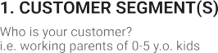

**Project**

**Title:**

**Smart Fashion Recommender Application**

**Project**

**Design**

**Phase**

**-**

**I**

-

**Solution**

**Fit**

**Template**

**Team**

**ID:**

**PNT2022TMID18036**

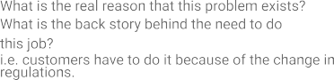

The Customers are Adults

and children

Users hard to find Trending

Fashion

Clothes.

Online shopping gives New

Collections

pros: Easy to use

cons: customer confused

when have lost of collections

Customers spend the time to

find the new fashion clothes

Money and Network

Connection

Customers need to be with

new fashions for current

trends

|  |  |  |  |  |  |  |  |  |
| --- | --- | --- | --- | --- | --- | --- | --- | --- |
|  | **3. TRIGGERS TR**  What triggers customers to act? i.e. seeing their neighbour installing solar panels, reading about a more efficient solution in the news. | | | **10. YOUR SOLUTION SL**  If you are working on an existing business, write down your current solution first, fill in the canvas, and check how much it fits reality.  If you are working on a new business proposition, then keep it blank until you fill in the canvas and come up with a solution that fits within customer limitations, solves a problem and matches customer behaviour.   |  | | --- | | Make a ChatBot Assistant for shopping with customers and send notifications when new collections arravied | | 1. **CHANNELS of BEHAVIOUR CH**     1. **ONLINE**   What kind of actions do customers take online? Extract online channels from #7     * 1. **OFFLINE**   What kind of actions do customers take offline? Extract offline channels from #7 and use them for customer development.   |  | | --- | | ONLINE: Customers buy the new clothes  OFFLINE: Customers will use the clothes | |  |
|  | Seeing neighbor Dressing Styles |  |
| **4. EMOTIONS: BEFORE / AFTER EM**  How do customers feel when they face a problem or a job and afterwards?  i.e. lost, insecure > confident, in control - use it in your communication strategy & design.   |  | | --- | | Felling Sad and Frustration > Selfconfident | | | |